PARUL INSTITUTE OF AYURVED & RESEARCH
SEMINAR/WEBINAR - 2025
WEBINAR ON IMPORTANCE OF SANSKRIT GRAMMER TO UNDERSTAND AYURVED TEXT
The Department of Samhita & Siddhant successfully organized a webinar on the 31st of January, 2024, from 11:00 AM to 12:00 PM, focusing on the critical topic “Importance of Sanskrit to Understand the Ayurveda Texts.” The session was conducted by Dr. Pooja Jani, an expert in Ayurveda and Sanskrit literature. The webinar was aimed at 1st Year BAMS students to emphasize the foundational role of Sanskrit in comprehending classical Ayurvedic scriptures.

Dr. Pooja Jani began the session by highlighting the historical context in which Ayurveda developed and how Sanskrit served as the primary medium of knowledge transmission. She elaborated on the unique grammatical structure, vocabulary, and syntax of Sanskrit that make it particularly suitable for expressing complex medical and philosophical ideas found in Ayurveda.

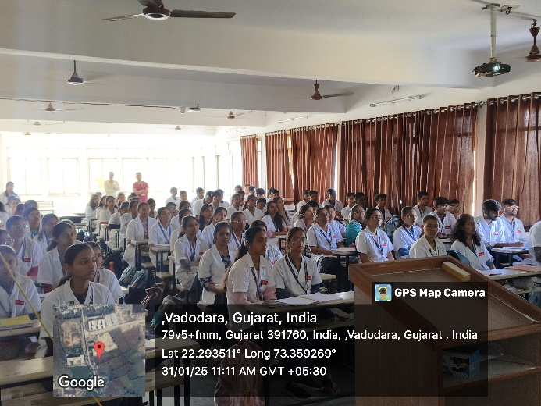 | 